Test Case: tc003_SPX_Dev5_Crear_Requisicion_Spot_Tipo_Cobro_CC_Urgent
Step 1 - Enter username and password and click to button Enter : Credentials Entered
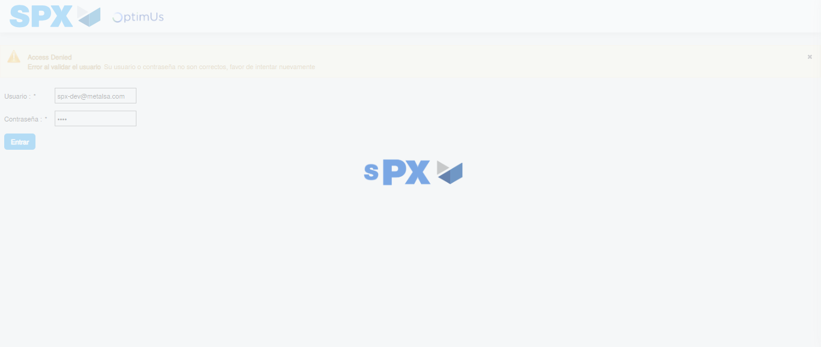Image file-name: QC_Testing-tc003_SPX_Dev5_Crear_Requisicion_Spot_Tipo_Cobro_CC_Urgent-1783357026579

Step 2 - Select to UEN and Access to Spot Buy Requisitions : UEN Correctly selected and Correct access
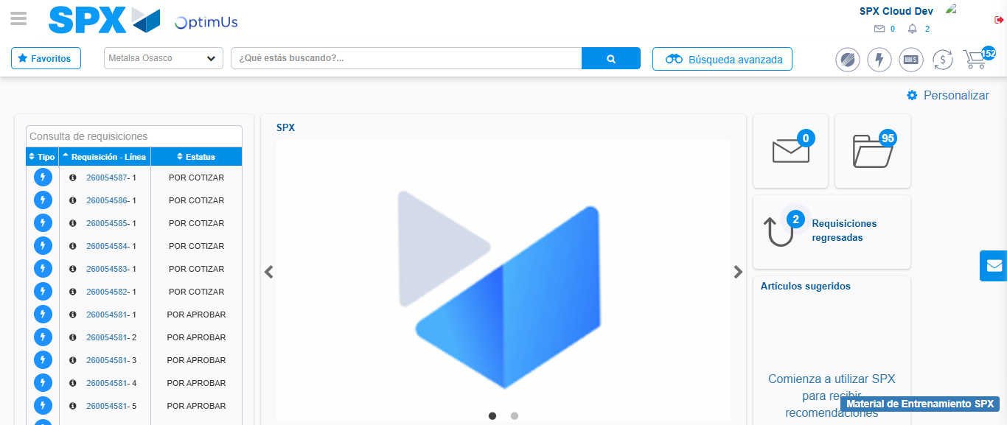Image file-name: QC_Testing-tc003_SPX_Dev5_Crear_Requisicion_Spot_Tipo_Cobro_CC_Urgent-1783357052255

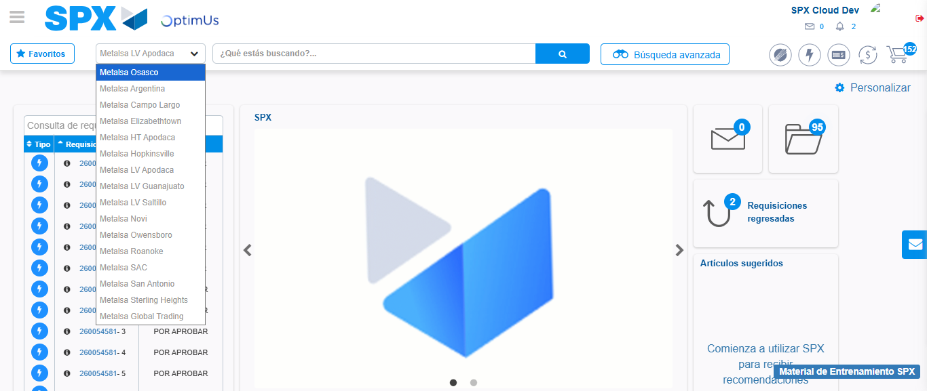Image file-name: QC_Testing-tc003_SPX_Dev5_Crear_Requisicion_Spot_Tipo_Cobro_CC_Urgent-1783357054856

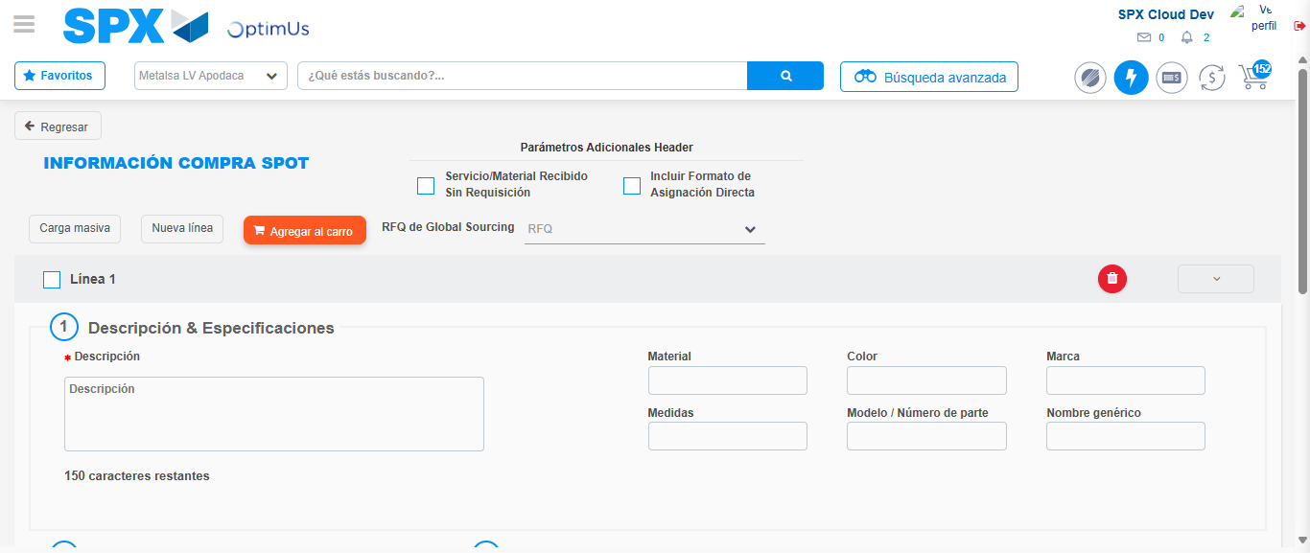Image file-name: QC_Testing-tc003_SPX_Dev5_Crear_Requisicion_Spot_Tipo_Cobro_CC_Urgent-1783357080811

Step 3 - Data Capture Spot Buy Requisition: Data captured correctly
Image file-name: QC_Testing-tc003_SPX_Dev5_Crear_Requisicion_Spot_Tipo_Cobro_CC_Urgent-1783357081106

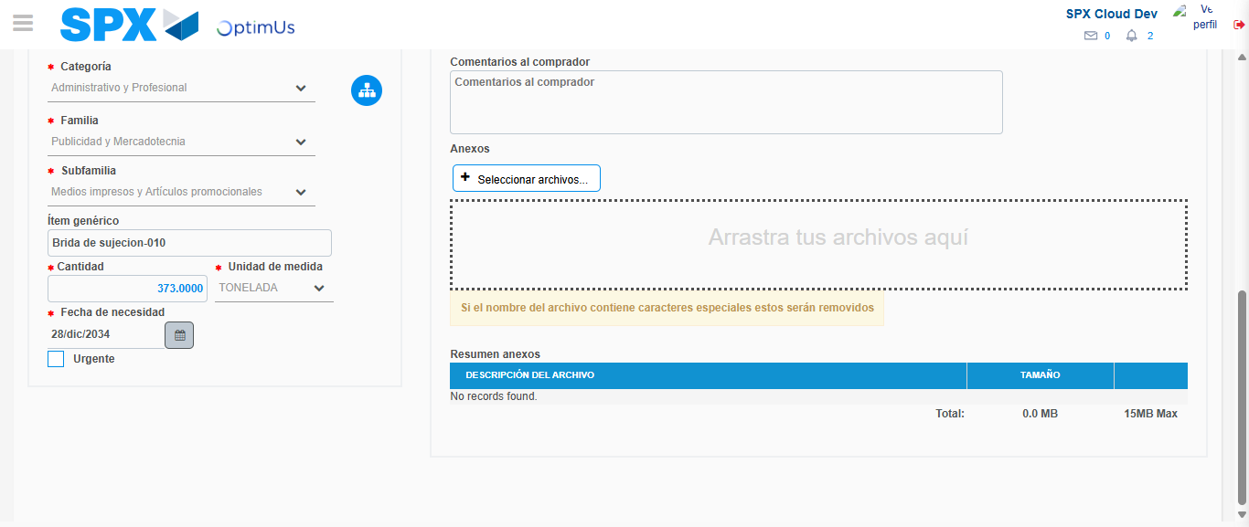Image file-name: QC_Testing-tc003_SPX_Dev5_Crear_Requisicion_Spot_Tipo_Cobro_CC_Urgent-1783357093050

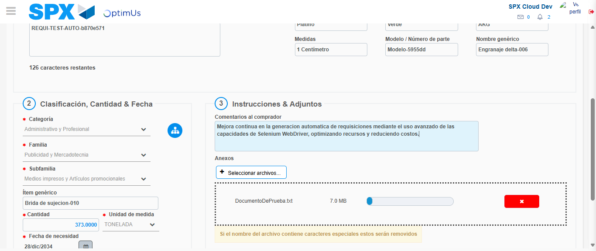Image file-name: QC_Testing-tc003_SPX_Dev5_Crear_Requisicion_Spot_Tipo_Cobro_CC_Urgent-1783357094003

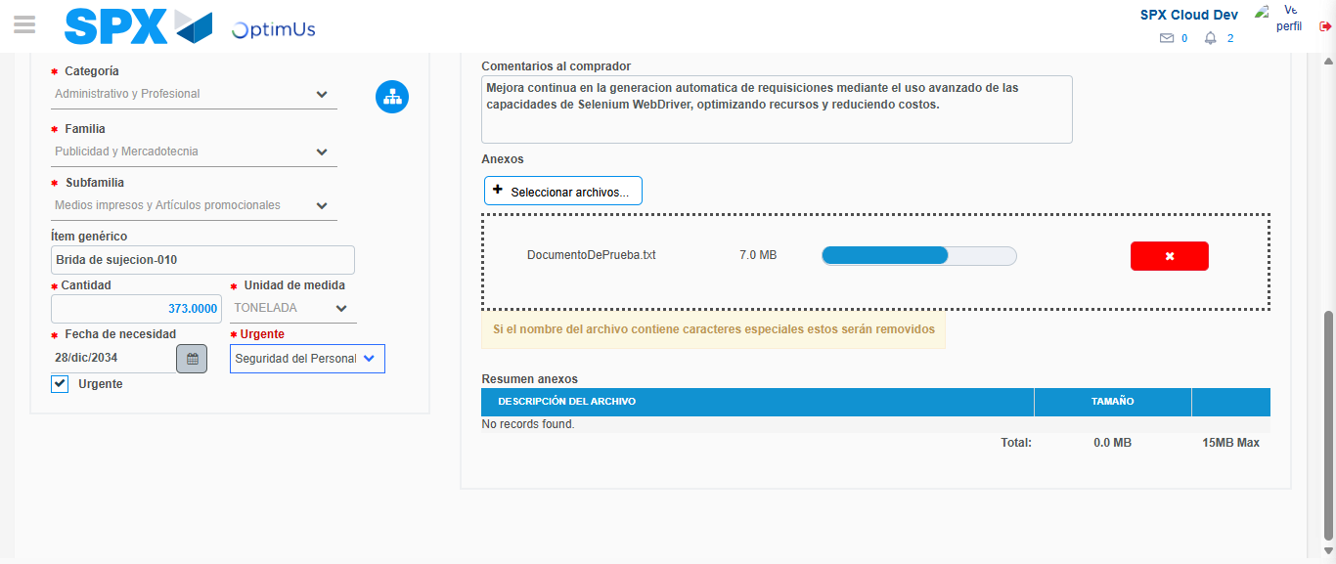Image file-name: QC_Testing-tc003_SPX_Dev5_Crear_Requisicion_Spot_Tipo_Cobro_CC_Urgent-1783357097928

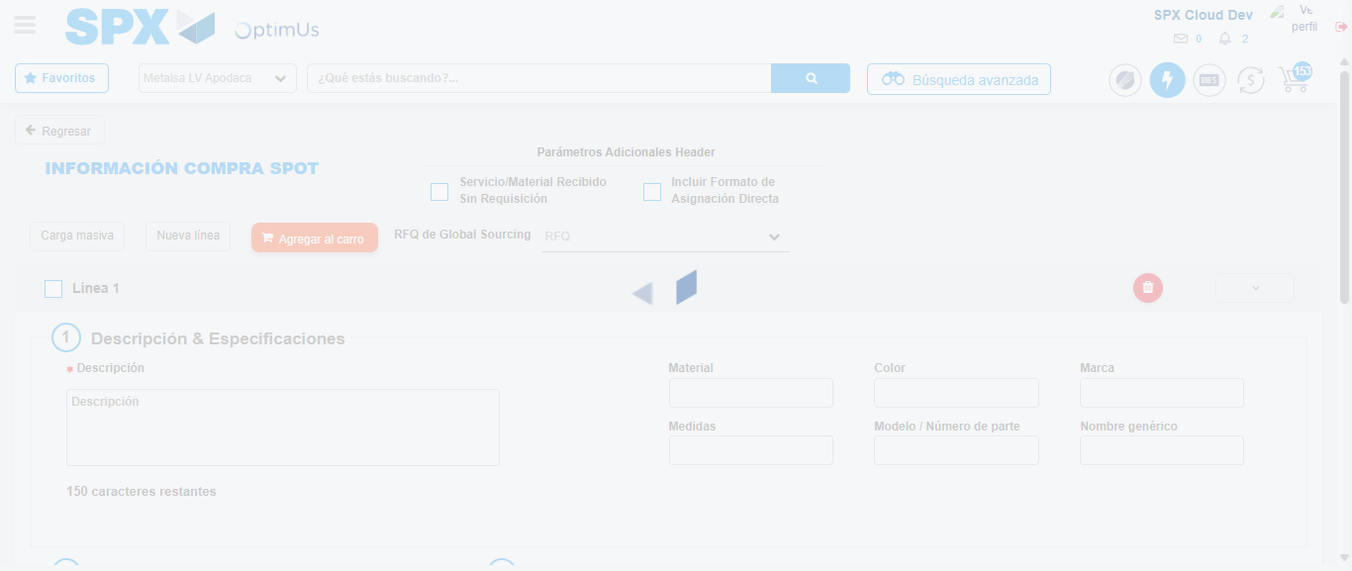Image file-name: QC_Testing-tc003_SPX_Dev5_Crear_Requisicion_Spot_Tipo_Cobro_CC_Urgent-1783357106779

Step 7 - Return to Main Page SPX : Return to Main Page SPX
Image file-name: QC_Testing-tc003_SPX_Dev5_Crear_Requisicion_Spot_Tipo_Cobro_CC_Urgent-1783357052255

Image file-name: QC_Testing-tc003_SPX_Dev5_Crear_Requisicion_Spot_Tipo_Cobro_CC_Urgent-1783357054856

Image file-name: QC_Testing-tc003_SPX_Dev5_Crear_Requisicion_Spot_Tipo_Cobro_CC_Urgent-1783357080811

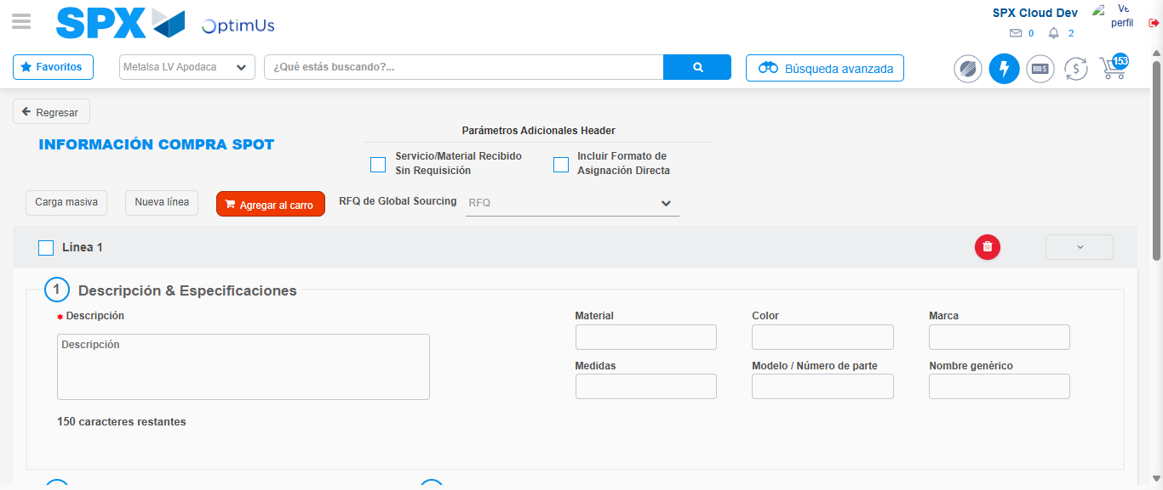Image file-name: QC_Testing-tc003_SPX_Dev5_Crear_Requisicion_Spot_Tipo_Cobro_CC_Urgent-1783357109056

Image file-name: QC_Testing-tc003_SPX_Dev5_Crear_Requisicion_Spot_Tipo_Cobro_CC_Urgent-1783357109276

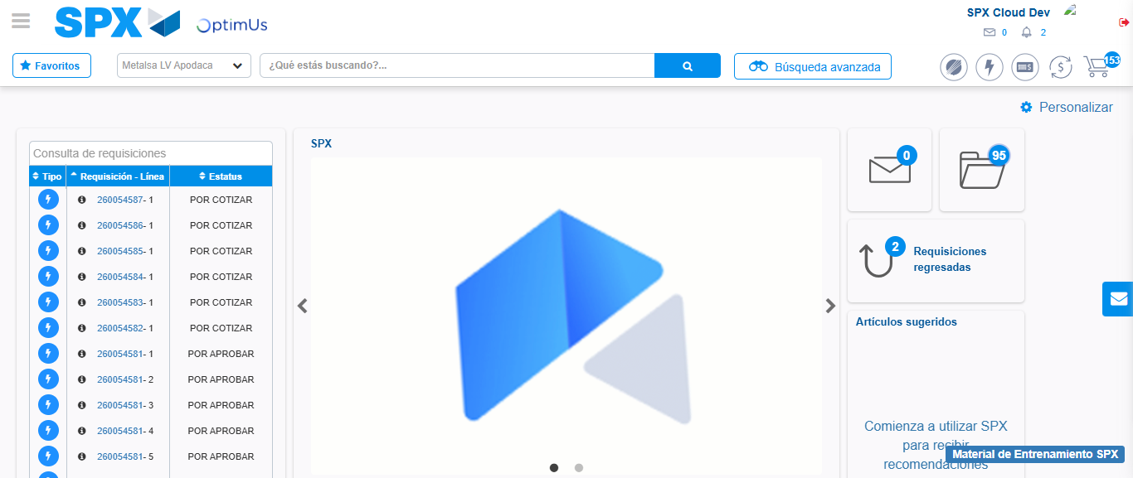Image file-name: QC_Testing-tc003_SPX_Dev5_Crear_Requisicion_Spot_Tipo_Cobro_CC_Urgent-1783357130823

Step 8 - Log Out : Log Out SPX
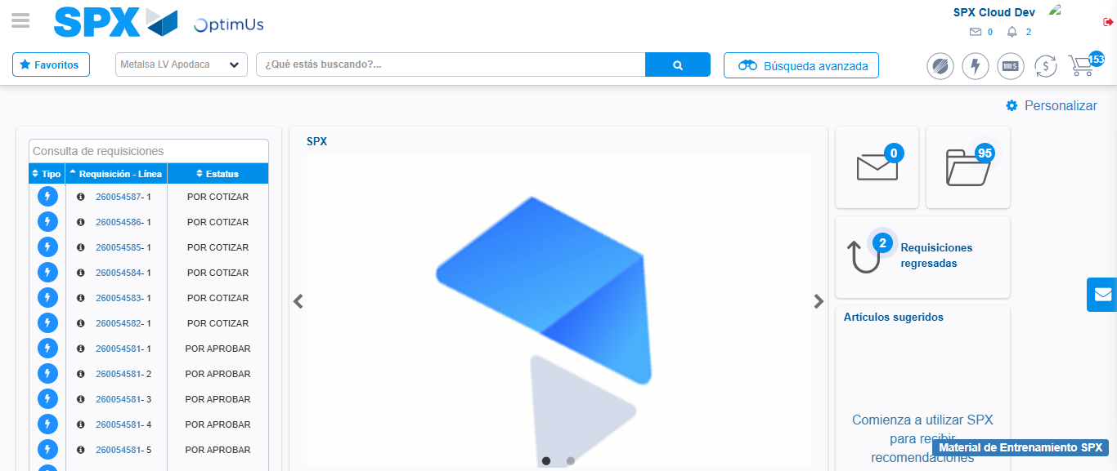Image file-name: QC_Testing-tc003_SPX_Dev5_Crear_Requisicion_Spot_Tipo_Cobro_CC_Urgent-1783357131159

